Contents

Falling Creek Oxygen Saturator (SSS) System Startup 1

Setting Flow Set Point on Pump Controller 12

Setting Flow Set point on Alicat Flow Controller 14

Falling Creek Oxygen Saturator (SSS) System Shutdown 20

Falling Creek Diffused Aeration / Mixing (DA/M) System Startup 25

Falling Creek Diffused Aeration / Mixing (DA/M) System Shutdown 29

Appendix A (Equipment List) 31

# Falling Creek Oxygen Saturator (SSS) System Startup

1. Electrical circuit 8,10,12 activated for lake pump AND 7,9,11 for air compressor
   1. Note for those not familiar with switches: circuit is activated if the switch is pointing towards the word “on”
2. Electrical circuit 3 activated for Air Sep PSA

1. Close or verify that all valves at Alicat flow controller are closed.

[GET NEW PICTURE OF ALICAT WITH ALL VALVES CLOSED AT NEW WALL LOCATION]

1. Plug in all wall units if previously unplugged (Alicat and PSA into Receptacle 3)

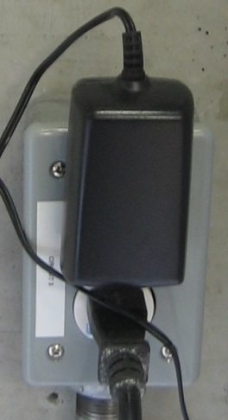

1. Turn refrigeration unit ON

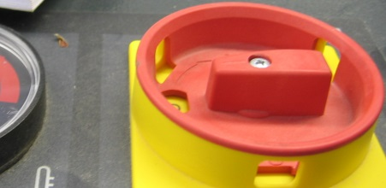 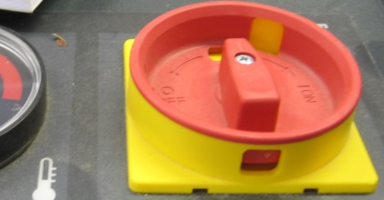

1. Verify refrigeration in green operation zone

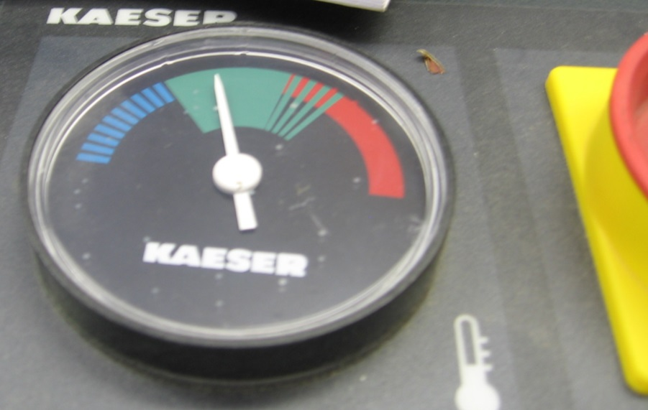

1. Press green button on the air compressor control panel to turn compressor ON.

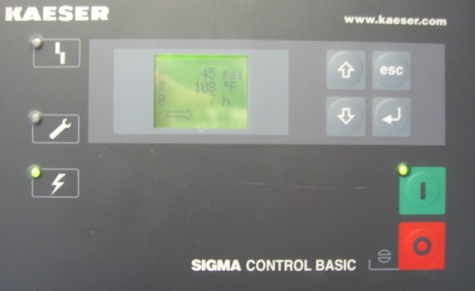

1. Wait until air compressor until air pressure reaches at least 60 psig before proceeding.

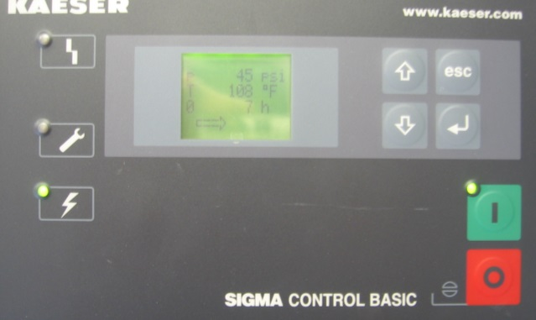 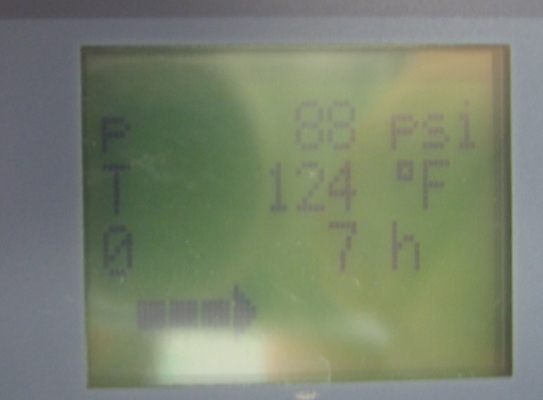

1. 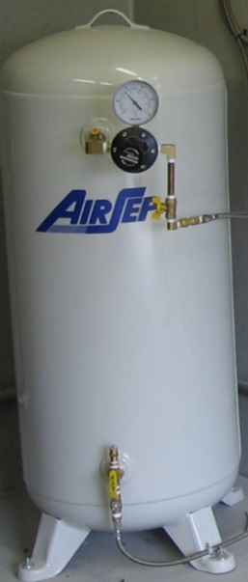Open *O2 isolation ball valve* and

verify *primary O2 ball valve* is closed

Primary O2 ball valve CLOSED

O2 isolation ball valve OPEN

1. Turn Auto/ Man switch to Auto

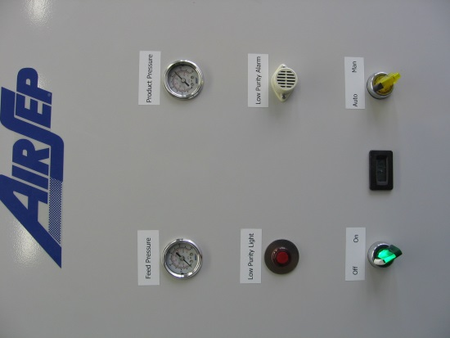 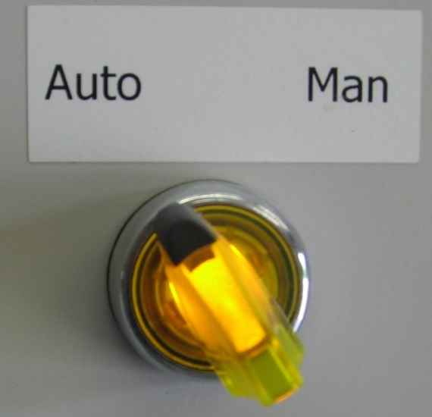

1. Turn on switch on Air Sep PSA main panel

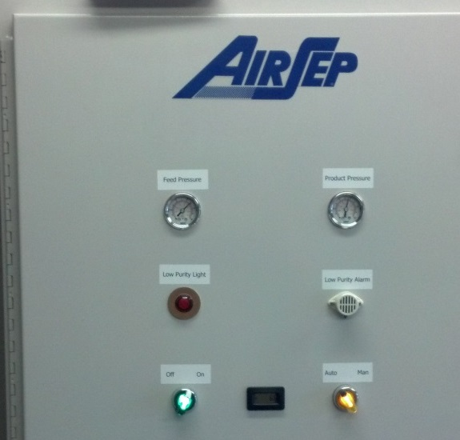 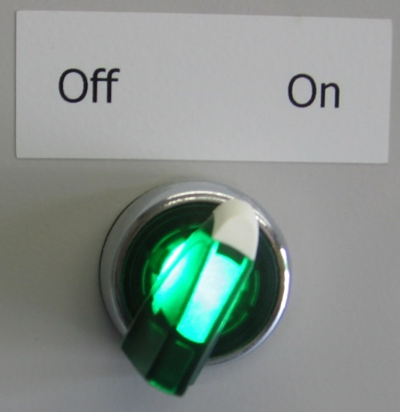

1. Low purity alarm may sound
2. Run PSA system until product pressure reaches 40 psig

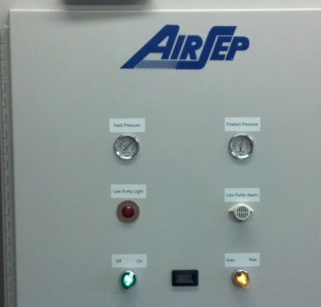 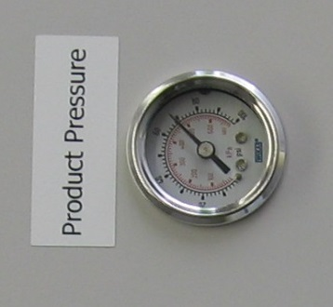

1. Check valve line up to operate large saturation chamber
   1. WIn, W3 Wout open
   2. Wvent, W1, W2 closed

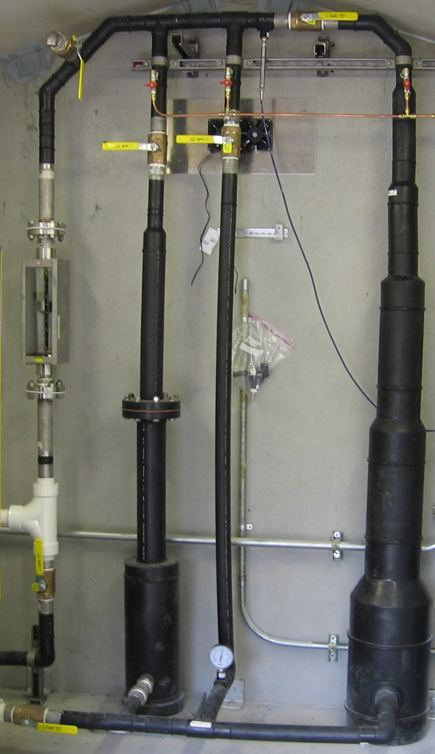

**W3**

W2

W1

Wvent

**Wout**

**Win**

1. Press green [Hand] button on IQ Pump controller to start water pump

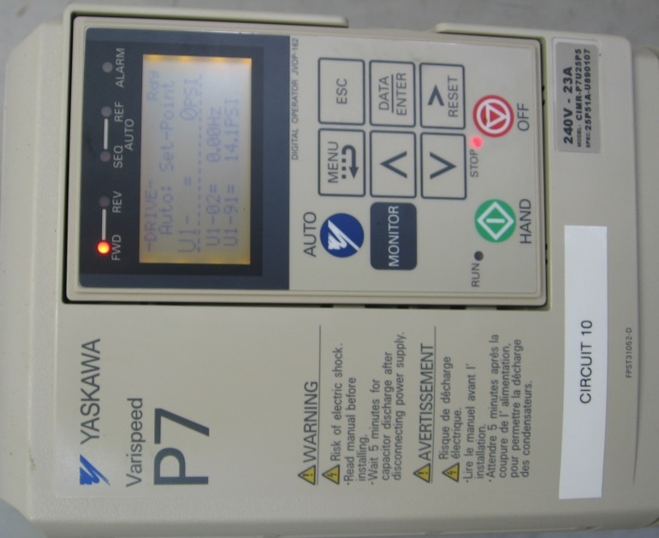 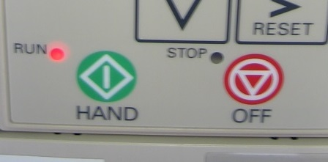

1. Set desired water flow rate (30 to 63 gpm) (See **Setting Flow Set Point on Pump Controller**)
   1. measured on rotameter in water input line to the left of saturators

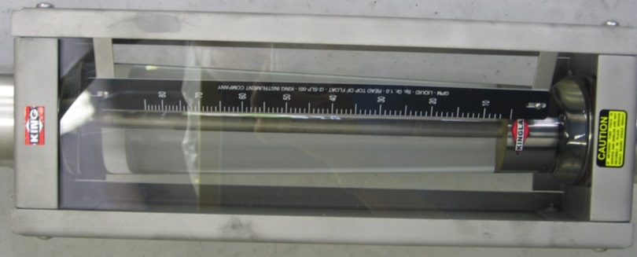

* 1. NOTE: Pump will start at previous set point

1. Verify Alicat isolation and bypass valves are closed. Open *Primary O2 ball valve*.

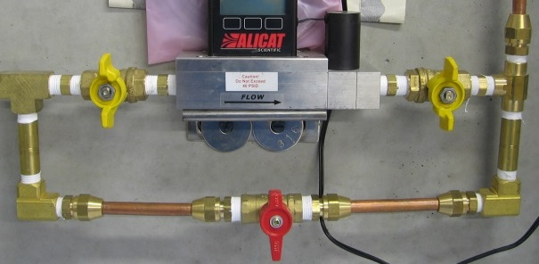 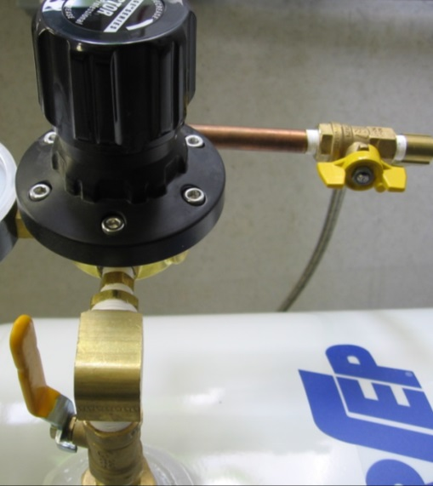

1. Verify oxygen input valve to saturator is CLOSED, then equalize the pressure across the Alicat Flow Controller by opening bypass valve [SAB] at Alicat flow

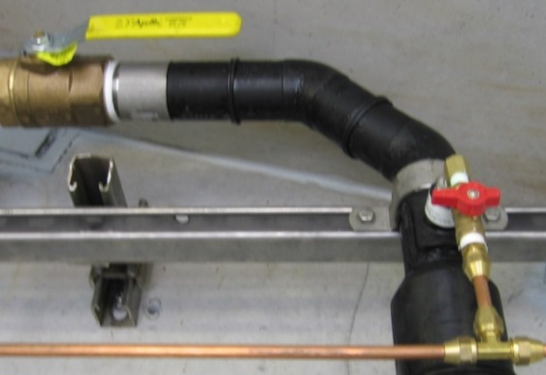 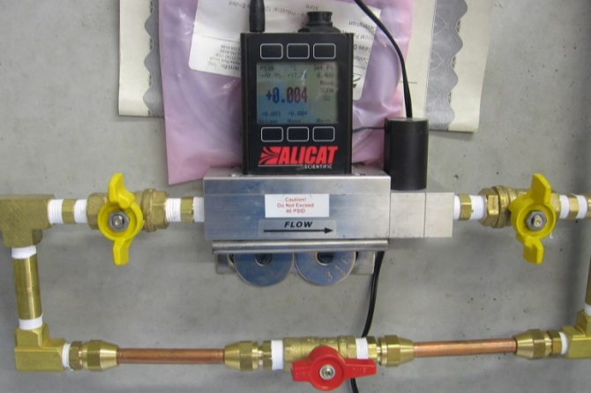

1. Open Alicat isolation valves [SAI1, SSAI2] at Alicat flow controller, then close bypass valve [AB] at Alicat flow controller

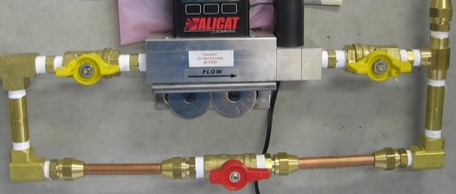 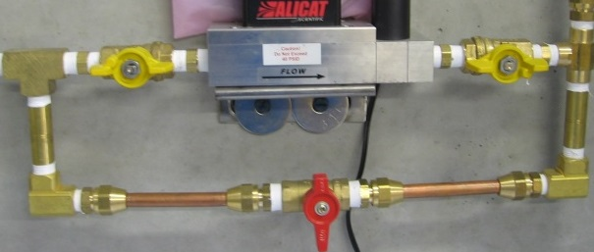

1. Verify the applied pressure to the Alicat is at least 5 psi > than current pump pressure.

NOTE: Always maintain at least 5 PSI but do NOT exceed 45 PSI differential between the Alicat and the Pump controller. To change the applied gas pressure, use the dial on the discharge to the AirSep receiver to increase or decrease pressure to the Alicat accordingly. Turn the dial while monitoring the pressure on the Alicat unit the desired pressure is achieved.

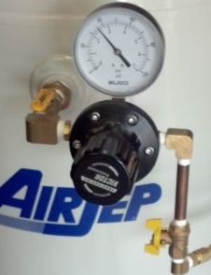

1. Set desired flow rate on Alicat flow controller (see **Setting Flow Set Point on Alicat Flow Controller**)
   1. NOTE: Controller will start at previous operation set point (0 to 0.5 SCFM)
2. OPEN the oxygen supply valve to the large saturator.

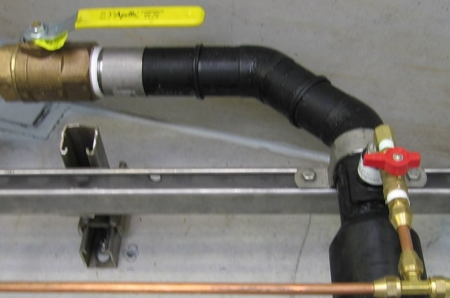 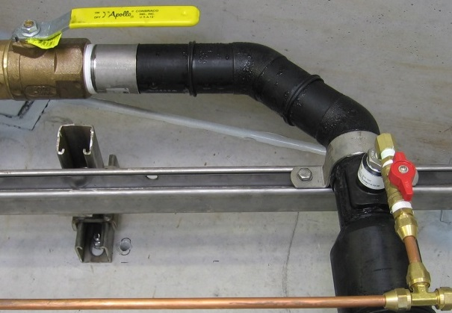

That’s it! Wait at least one hour, then check to make sure that oxygen has increased in the hypolimnion. You did it!

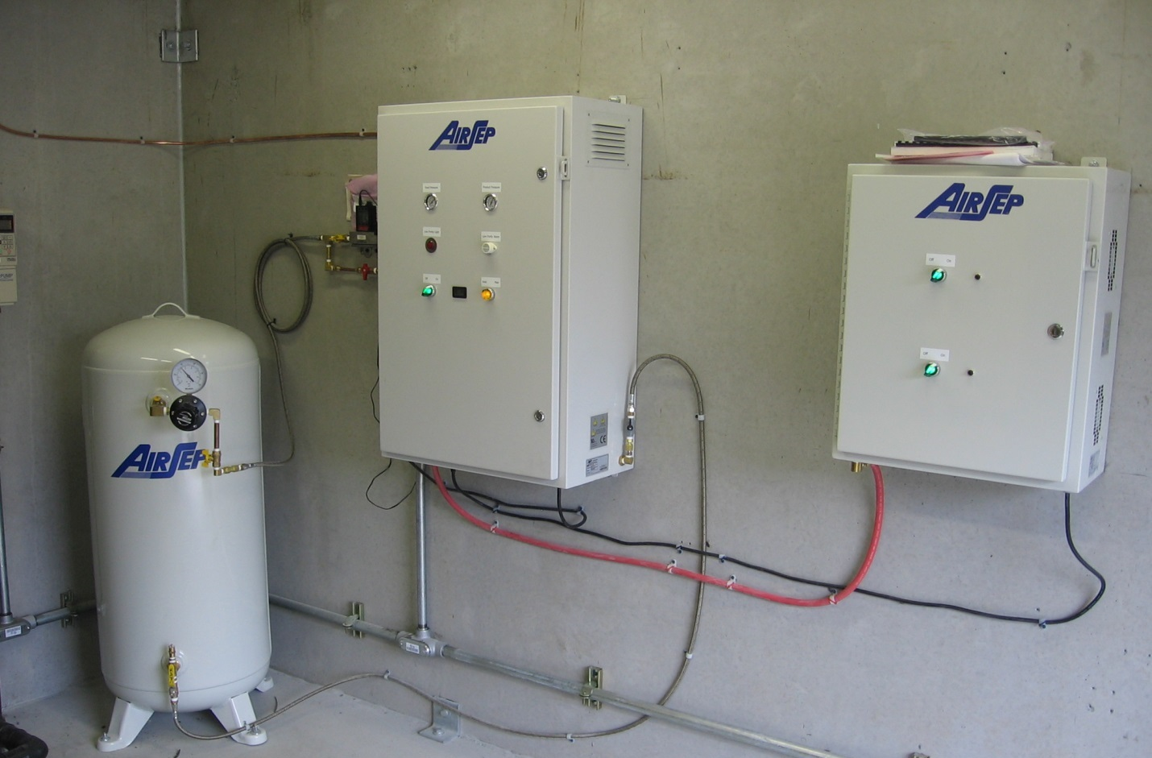

O2 supply valve

Primary O2 ball valve

O2 isolation ball valve

AirSep O2 Receiver

Alicat flow controller

AirSep PSA Unit

AirSep Compressor(s)

[update this photo]

NOTE: If during SSS operation, bubbles are observed in the lake, increase the pump flow rate. It is recommended to increase the pump flow rate by increasing the frequency setting 5 Hz at a time until the bubbles are no longer observed on the surface. If maximum pump operation (60Hz) is achieved and bubbles are still observed, decrease the applied gas flow rate by 0.05 SCFM increments until the bubble disappear. It will be necessary to wait 15 – 30 minutes between each system change to verify the system has reached a new steady state.



Example of bubbles from SSS operation.

NOTE 2: If you arrive at FCR and find that the SSS is at the surface of the reservoir, this is likely because there was a power surge and the pump shut off. If the pump shuts off, water is not being pushed through the system but air still is. This decreases the density of the pipe, making it float. To solve this problem, simple go in the shed, check that the breakers are still on, and then turn on the pump (press the green hand button).

NOTE 3: To clear the intake grate, first check the pressure in the brown tank on the left of the shed. This should read somewhere around 40 PSI.

Next, ensure that the timer is plugged in (shown in the photo above). Press the on button on the timer.

Flip this switch (grey box) to ON, then look for bubbles at the surface of the reservoir. When you see bubbles you can turn the switch off. Success!

## Setting Flow Set Point on Pump Controller

1. From the main screen press MENU (to select *Operation*) then Press DATA/ENTER

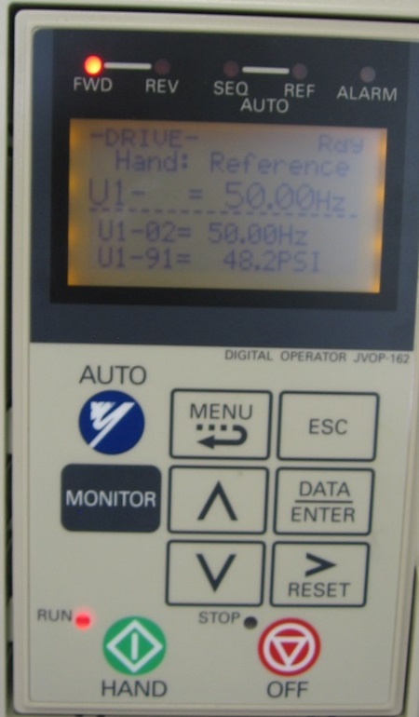 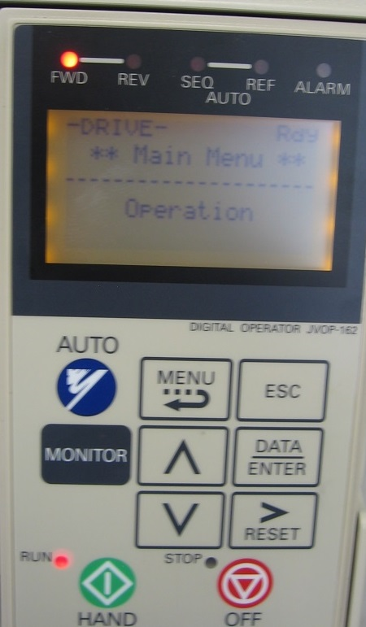

1. Use up/down arrows to select U1 -01 (frequency, Hz set point), then press the DATA/ENTER button

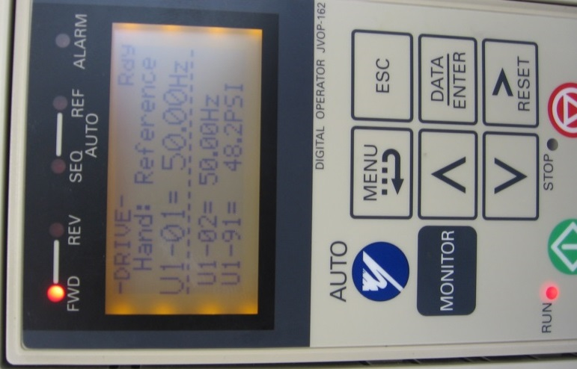 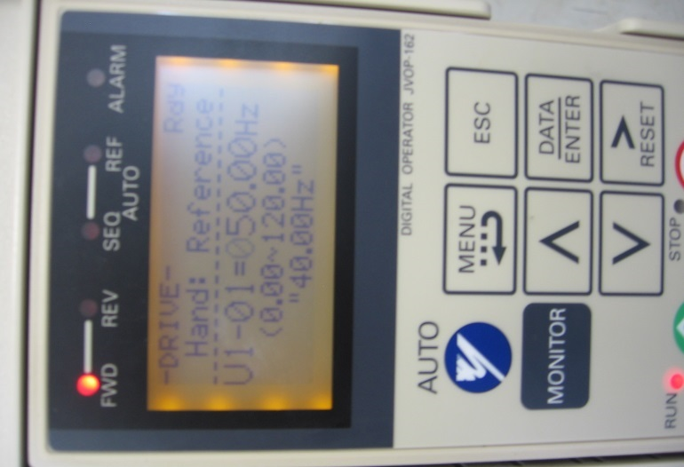

1. Use the right arrow (>RESET button) to select appropriate 10’s or 1’s column. Then use the up/down arrow to change set point accordingly.

 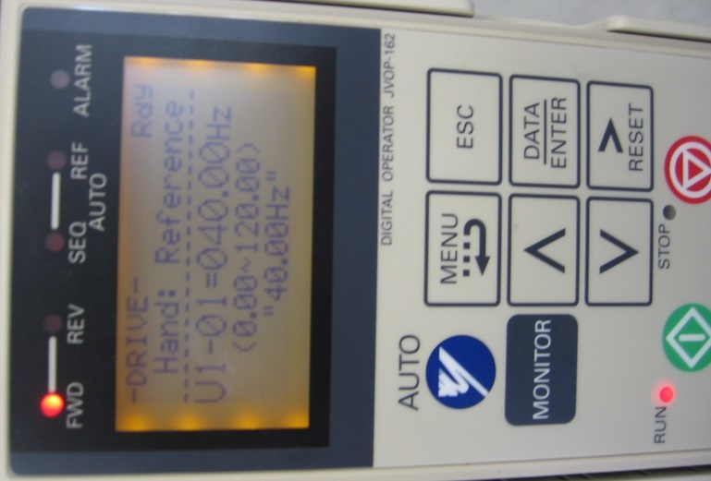

1. Press DATA/ENTER button to accept new value, then press ESC to return to main screen

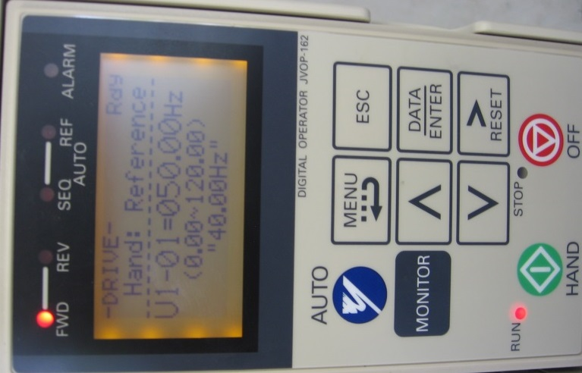 

## Setting Flow Set point on Alicat Flow Controller

1. Press “Main” button to access the Main Menu on the Alicat Flow controller

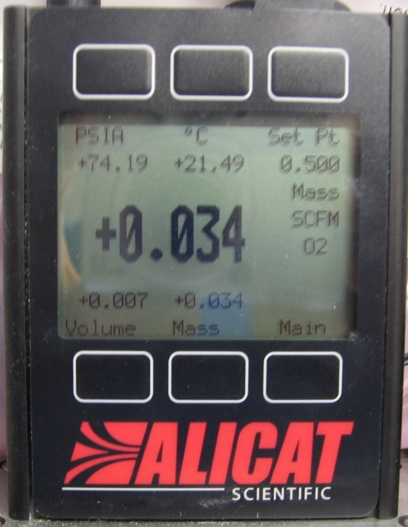

1. Press “Control Setup” to access the Setup menu

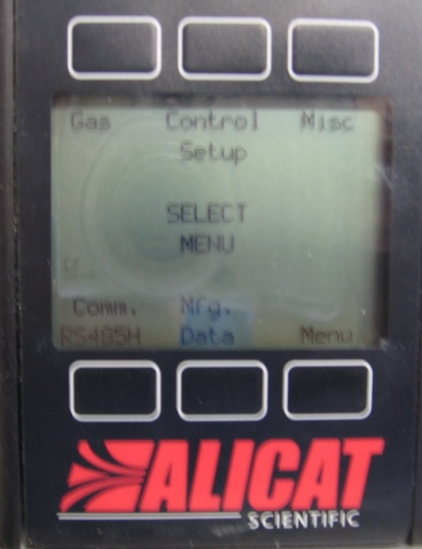

1. Make sure *Local* is selected under the “Input” column. If not, press the “Input” button to toggle to *Local*.

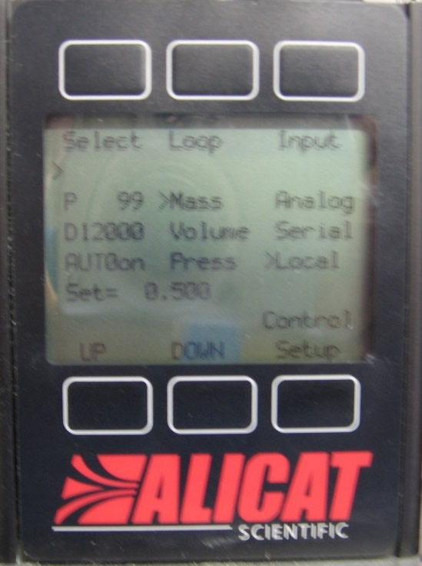

1. Press the “Select” button to toggle down to *Set*.

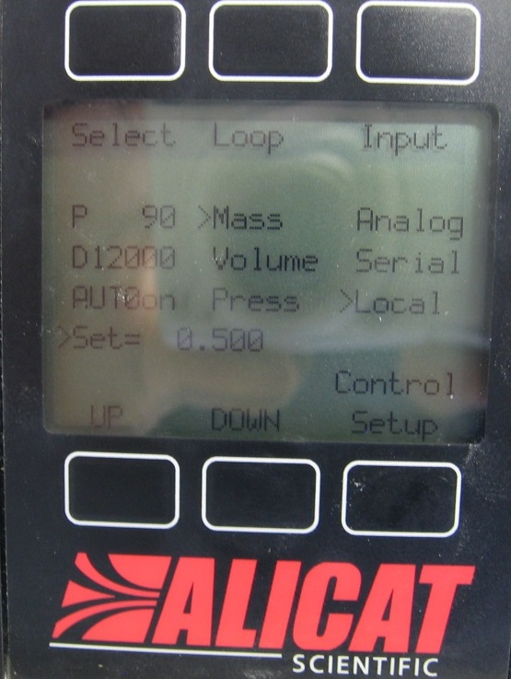

1. Use the UP or DOWN buttons to select the appropriate set point. (Note: the maximum output from the PSA is 0.53 SCFM, therefore is recommended to maintain the flow set point at or below 0.50 SCFM.



1. Press “Control Setup” to return to the Main Menu.



1. Press Menu to return to the display showing the current data.

 

NOTE: On the Alicat Flow Controller for the aeration system, the Set Point can be changed by pressing the button above SETPT then use SELECT to choose the decimal with the arrow and the UP and DOWN buttons to change the value.

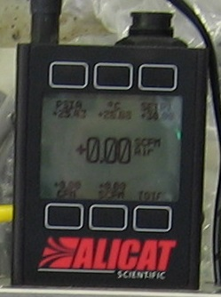

If the set point cannot be changed, make sure the SEPT SOURCE (via the CONTROL SETUP screen) is selected to FRONT PANEL.

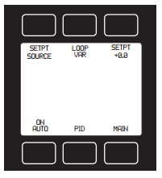 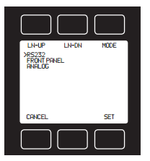

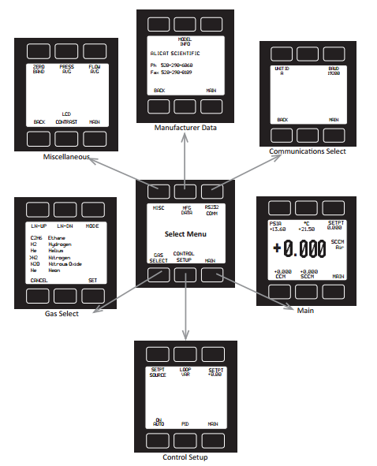

Hierarchy of menus for the aeration system Alicat Flow Controller, which is slightly different than the oxygen system flow controller.

# Falling Creek Oxygen Saturator (SSS) System Shutdown

1. CLOSE oxygen supply valve to large saturator

 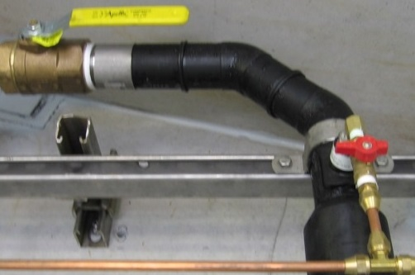

1. CLOSE upstream and downstream valves to Alicat Flow Controller then disconnect power supply.

 

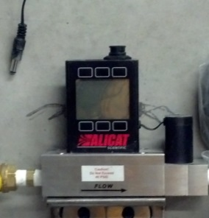

1. Close the Primary O2 ball valve



1. Check PSA operation is in AUTO

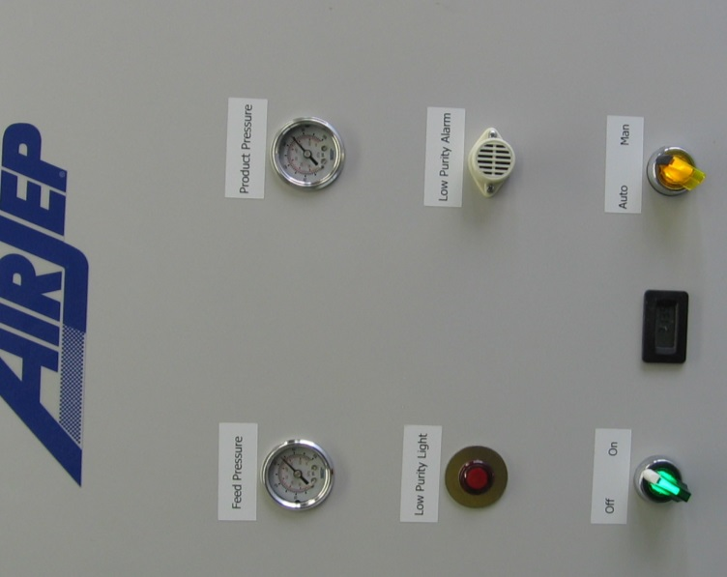 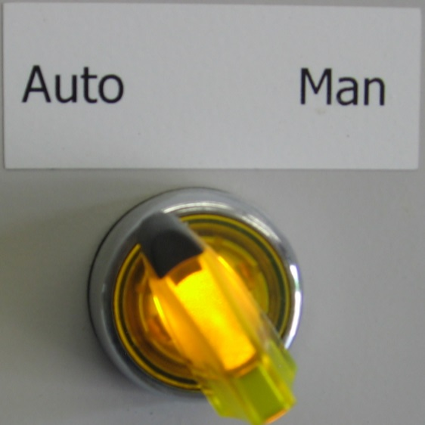

1. Allow PSA unit to run until the PSA unit enters standby mode (yellow light turns off).
2. Press the STOP button on the Yaskawa pump controller. (Pump with wind down and shut off).

 

1. After PSA unit enters standby mode, CLOSE Oxygen isolation ball valve.

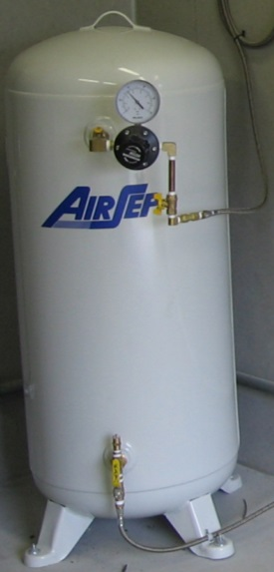

1. Turn the (green) switch on the front panel of the PSA unit compressors to OFF

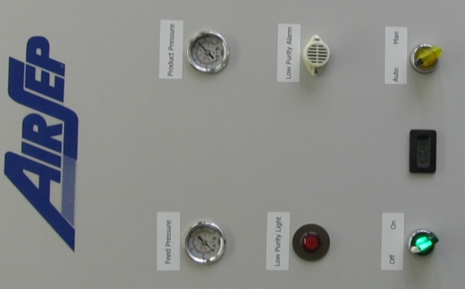 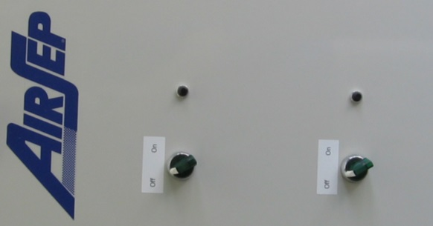

1. Press the OFF button on the air compressor control panel.



1. Turn the refrigeration unit OFF.

 

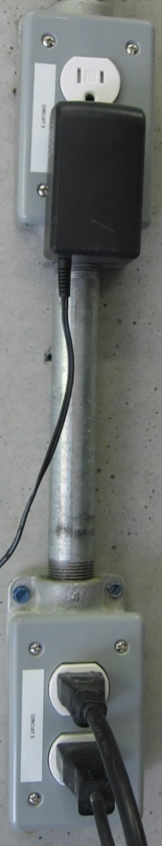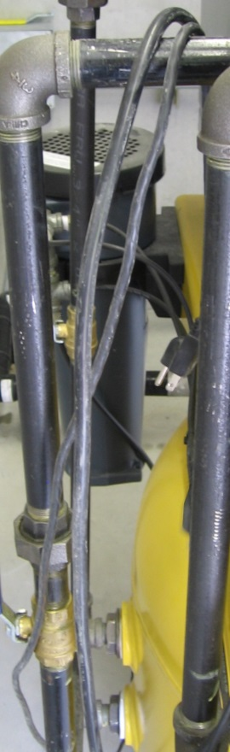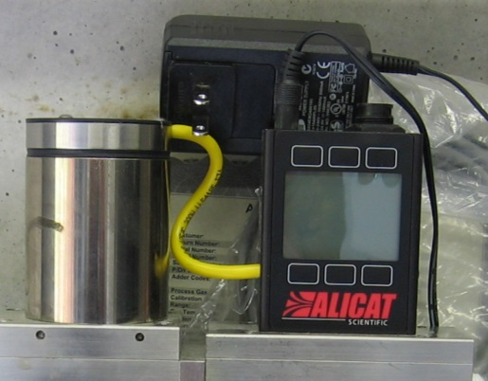

1. Unplug the condensate drain,

refrigeration unit, and

the Alicat flow controller

from circuit 5.

1. Clean the air inlet filters to the PSA compressors to have them ready for startup.

[GET PICTURE OF WHERE FILTERS ARE]

1. Unplug PSA and power supply to Alicat flow controller plugged into circuit 3.

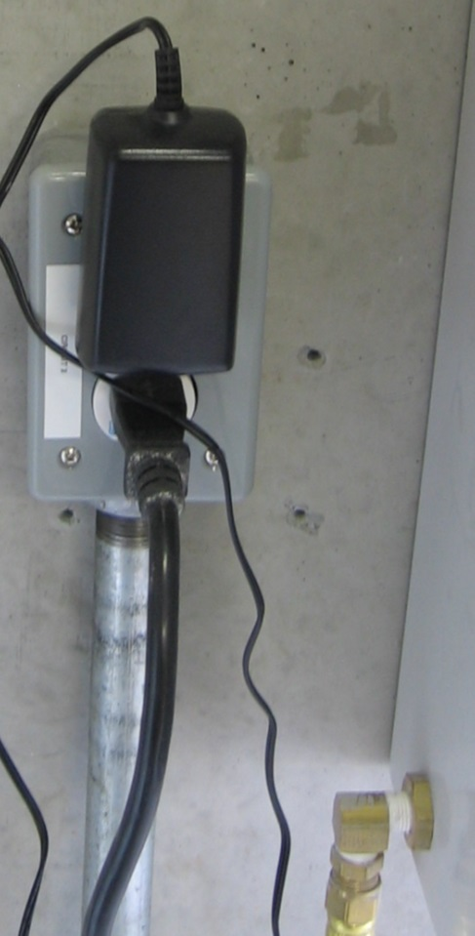

1. Switch breakers 8,10,12 (LAKE PUMP) and 3 (RECPT. AIR SEP) and breakers 7,9,11 (air compressor) to OFF.

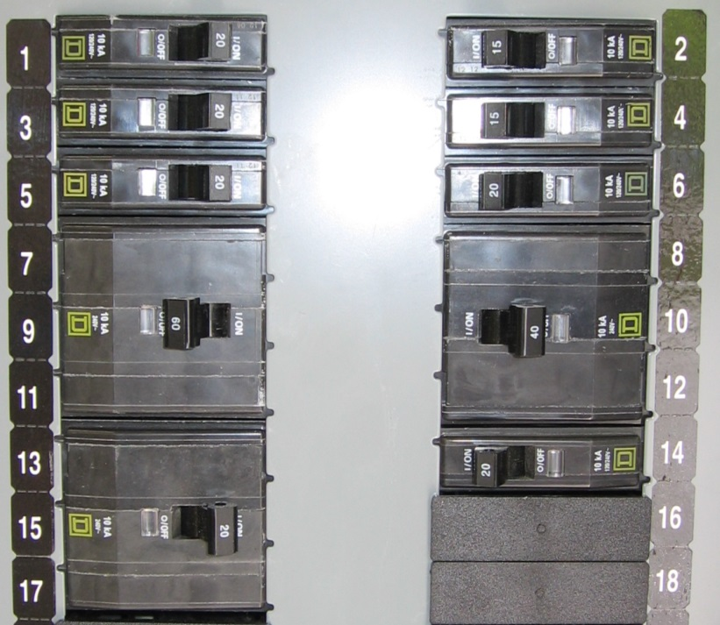

**Falling Creek Diffused Aeration / Mixing (DA/M) System Startup**

1. Turn ON Electrical circuits 7,9,11 (Air Comp) and 5 (RECPT. at Air Comp) for air compressor and circuit 5 for Alicat Flow Controller, refrigeration unit, and condensate blow off.

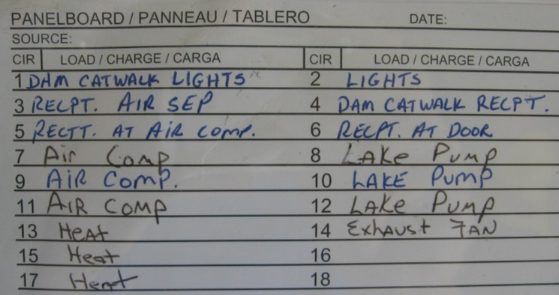 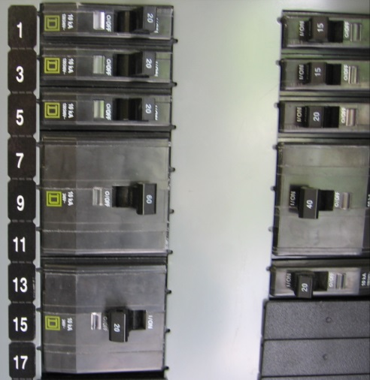

1. Make sure all valves at Alicat flow controller are CLOSED.

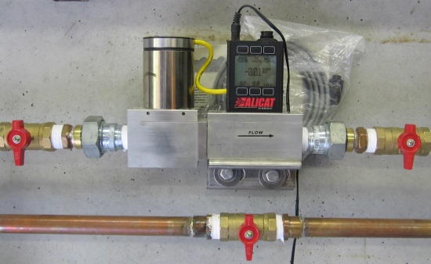

1. Make sure air isolation valve [DAI] is CLOSED.

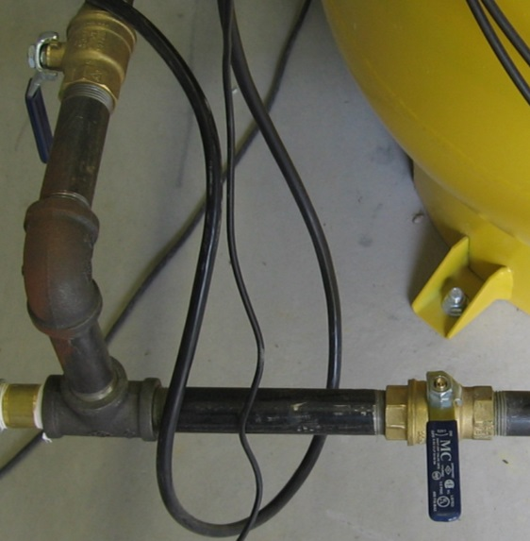

1. 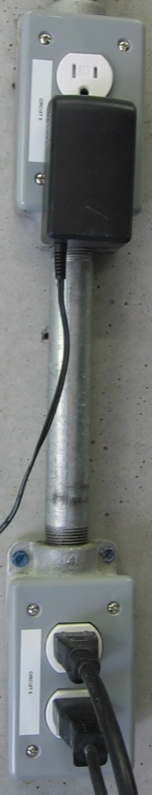Plug in refrigeration unit,

condensate blow off, and

Alicat Flow Controller

1. Turn refrigeration unit ON

 

1. Verify refrigeration in green operation zone



1. Press green button on the air compressor control panel to turn compressor ON.



1. Wait until air compressor until air pressure reaches at least 60 psig before proceding.

 

1. Open air isolation valve [DAI]

 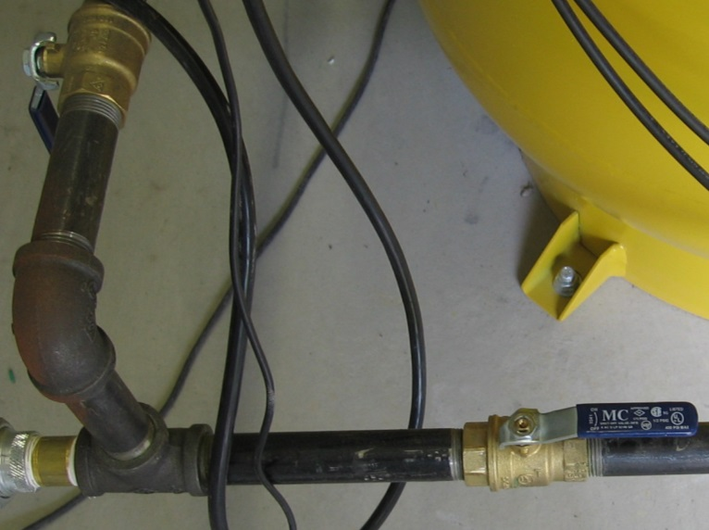

1. Open isolation valves [DAI1, DAI2] at Alicat flow controller

 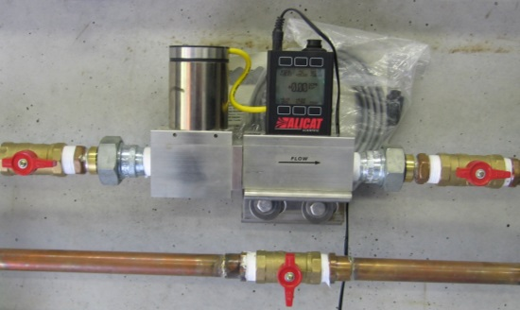

1. Set desired flow rate on Alicat flow controller (See **Setting flow Set point on Alicat Air (DA/M) Flow Controller**)
   1. NOTE: Controller will start at previous operation set point (30 scfm)

# Falling Creek Diffused Aeration / Mixing (DA/M) System Shutdown

1. CLOSE the upstream and downstream valves to the Alicat Flow Controller, then disconnect the power supply to the Alicat.

 

1. CLOSE the isolation valve on the discharge from the compressor receiving tank.

 

1. Press the OFF button on the air compressor control panel.



1. Turn the refrigeration unit OFF.

 



1. Unplug the condensate drain,

refrigeration unit, and

the Alicat flow controller

from circuit 5.

1. Switch electrical circuit breakers 7,9,11 (Air Comp) and 5 (RECPT at Air Comp) to OFF deactivated power to the air compressor and circuit 5.

 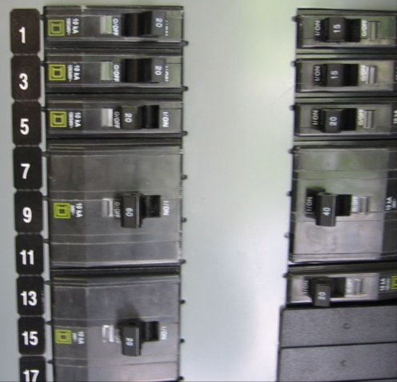

# Appendix A (Equipment List)

**Equipment Manufacturer Name Model Number Serial Number**

Air Compressor Kaeser SX 7.5 100891.1 1064

Pump Controller Yaskawa Varispeed P7 CIMR P7U25P5 1W122983770003

PSA System Air Sep Centrox AS074-1 110026-1

Flow Controller (O2) Alicat MCP100SLPM-D-1-485 55452

Flow Controller (Air) Alicat MCR100SLPM-D-1-485 82350